# Experiment: Time Series Data Visualization

## 1. Importing Necessary Libraries

Explanation:  
This section imports the necessary libraries required for time series analysis, visualization, and data representation.

Corresponding Code:

import pandas as pd  
import matplotlib.pyplot as plt  
import seaborn as sns

## 2. Loading the Dataset

Explanation:  
The dataset is loaded from a CSV file into a pandas DataFrame. The dataset file (OzoneHole_Data.csv) must be in the working directory.

Corresponding Code:

df = pd.read_csv("OzoneHole_Data.csv")

## 3. Visualizing the Time Series Data

Explanation:  
This section includes various plots to visualize trends, patterns, and distribution in the time series data.

Corresponding Code:

plt.figure(figsize=(12,5))  
sns.set_style("darkgrid")  
plt.subplot(2,1,1)  
plt.plot(df["Year"], df["Hole Area"], marker="o", linestyle="-")  
plt.title("Hole Area over Years")  
plt.subplot(2,1,2)  
plt.plot(df["Year"], df["Minimum Ozone"], marker="o", linestyle="-", color="red")  
plt.title("Minimum Ozone over Years")  
plt.show()

Generated Visualization:

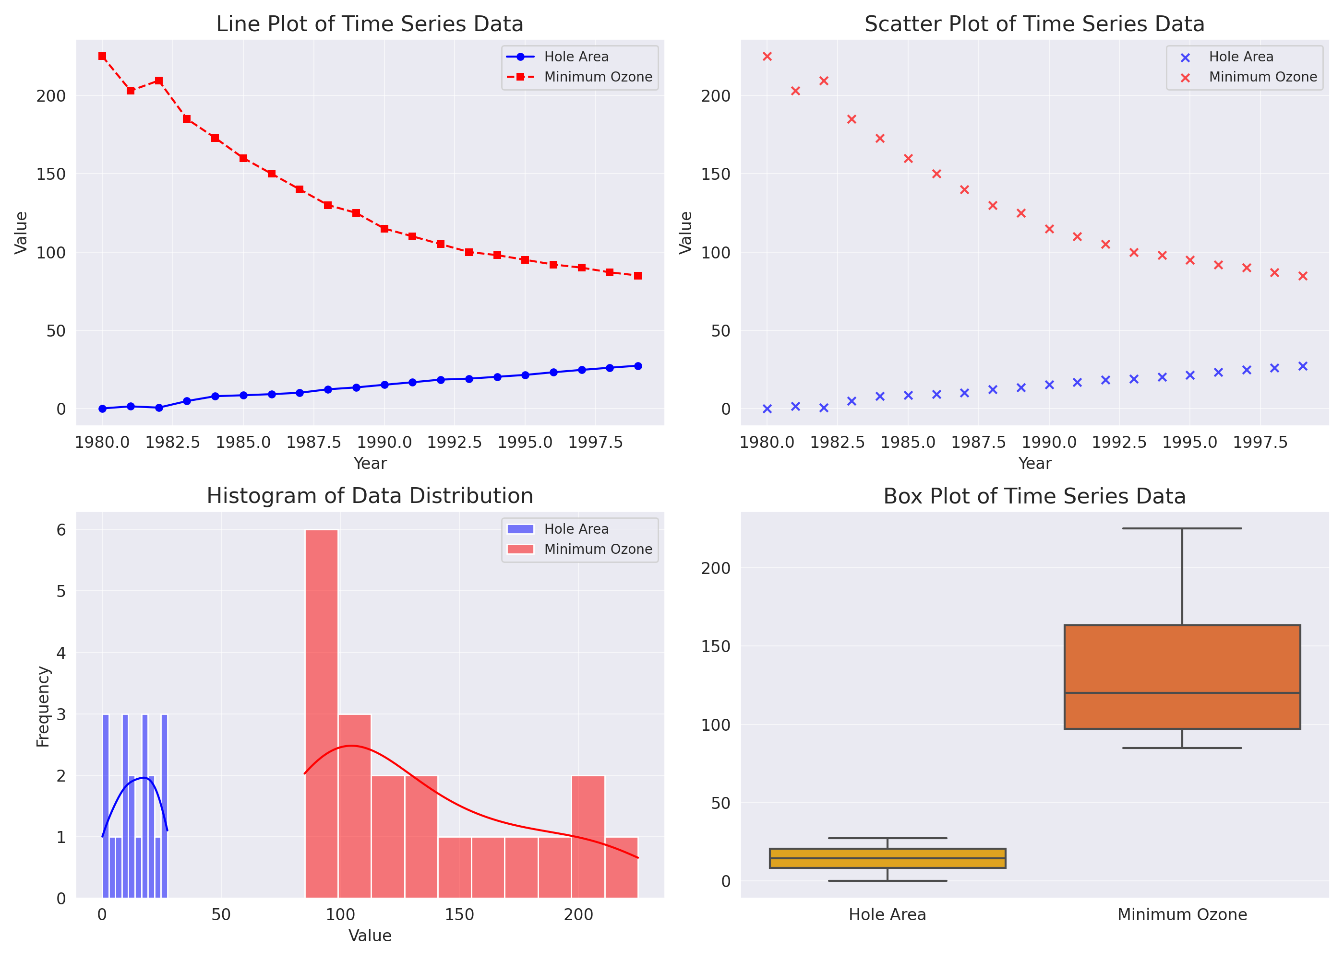

## 4. Additional Visualizations

Explanation:  
Scatter plots help observe distributions, histograms show frequency distributions, and box plots highlight outliers and spread.

Corresponding Code:

sns.scatterplot(x=df["Year"], y=df["Hole Area"], label="Hole Area")  
sns.scatterplot(x=df["Year"], y=df["Minimum Ozone"], label="Minimum Ozone")  
plt.title("Scatter Plot")  
plt.show()  
  
sns.histplot(df["Hole Area"], bins=10, kde=True, label="Hole Area")  
sns.histplot(df["Minimum Ozone"], bins=10, kde=True, label="Minimum Ozone")  
plt.title("Histogram of Data Distribution")  
plt.show()  
  
sns.boxplot(data=df[["Hole Area", "Minimum Ozone"]])  
plt.title("Box Plot of Time Series Data")  
plt.show()

## 5. Conclusion

Result:  
The visualization of time series data allows us to identify trends, patterns, and distributions effectively. Various plots provide deeper insights into data behavior.